Analytical Problem Solving
Delivery Robot in a Warehouse — Intelligent Agent and Search Algorithms
Introduction
Artificial Intelligence enables intelligent agents to perceive their environment, make decisions, and perform actions to achieve specific goals. Search algorithms help agents explore possible states and find suitable paths from an initial state to a goal state. In robotic navigation, these techniques can be used to find efficient routes while avoiding obstacles. Breadth-First Search (BFS) and Depth-First Search (DFS) are two fundamental uninformed search algorithms that differ in their exploration strategy, memory usage, completeness, and optimality.

1. Problem Statement
A delivery robot operates in a 5 × 5 warehouse grid. The robot starts at cell (1,1) and must deliver a package to the destination cell (5,5).
The warehouse contains blocked cells representing shelving units:
- (2,2)
- (2,3)
- (3,3)
- (4,2)
- (4,4)
The robot can move in four directions:
- Up
- Down
- Left
- Right
Diagonal movement is not allowed. Each movement has a uniform cost of 1.
The objective is to find a valid path from (1,1) to (5,5) using search algorithms such as Breadth-First Search (BFS) and Depth-First Search (DFS).

a. Formal Intelligent Agent Problem
An intelligent agent is an entity that perceives its environment through sensors and acts upon the environment through actuators to achieve a desired objective.
For the warehouse robot:
- Agent: Delivery robot
- Environment: 5 × 5 warehouse grid
- Initial location: (1,1)
- Goal location: (5,5)
- Obstacles: Blocked cells containing shelves
PEAS Description
PEAS stands for:
- P – Performance Measure
- E – Environment
- A – Actuators
- S – Sensors
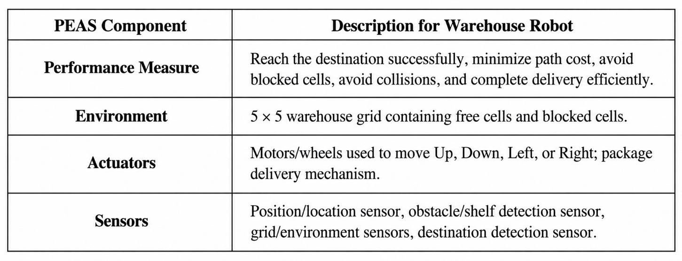
Performance Measure
The robot should:
- Successfully reach cell (5,5).
- Avoid all blocked cells.
- Minimize the number of movements.
- Avoid unnecessary movement.
- Deliver the package safely.
- Operate within the boundaries of the warehouse.

b. Type of Intelligent Agent
Suitable Agent: Goal-Based Agent
The goal-based agent is the most suitable type of intelligent agent for this problem.
A goal-based agent selects actions based on whether they help it achieve a specified goal.
Here, the robot has a clearly defined goal:
Reach cell (5,5) from cell (1,1) while avoiding blocked cells.
The robot must evaluate possible movements and select a sequence of actions that eventually reaches the destination.
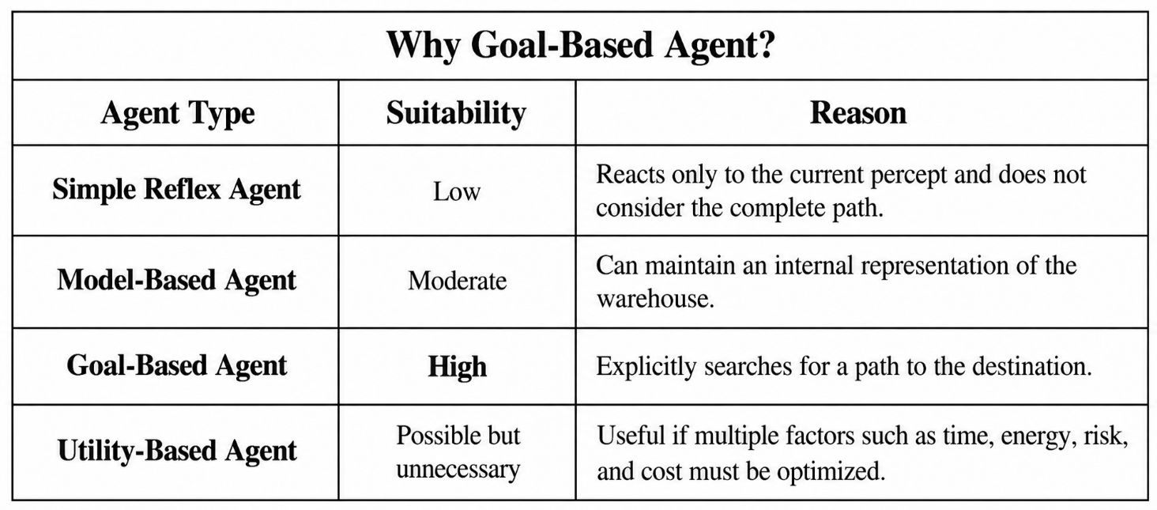

For this problem, the primary objective is simply to reach (5,5) while avoiding obstacles and minimizing movement cost.
Therefore:
The warehouse delivery robot is best modeled as a goal-based agent using a search algorithm such as BFS.

c. Formal Search Problem Definition
The warehouse navigation problem can be represented as a classical search problem.
A search problem consists of:
- Initial State
- Goal State
- Actions
- Transition Model
- Path Cost

1. Initial State
The robot starts at:
$$Initial State=\left(1 , 1\right)$$

2. Goal State
The destination is:
$$Goal State=\left(5 , 5\right)$$

3. Actions
The robot can perform four actions:
$$Actions=\left\{U , p , D , ownLeftRight\right\}$$
An action is allowed only when:
- The resulting cell is inside the 5 × 5 grid.
- The resulting cell is not blocked.

4. Blocked States
The blocked cells are:
$$B=\left\{\left(2 , 2\right) , \left(2 , 3\right) , \left(3 , 3\right) , \left(4 , 2\right) , \left(4 , 4\right)\right\}$$
These cells cannot be entered by the robot.

5. Transition Model
The transition model determines the new position of the robot after an action.
For a state:
$$\left(x , y\right)$$
the possible transitions are:
Action | New State
Up | (x−1, y)
Down | (x+1, y)
Left | (x, y−1)
Right | (x, y+1)
The transition is valid only if the new cell:
- lies within rows 1–5,
- lies within columns 1–5,
- is not blocked.

6. Path Cost
Each movement has a uniform cost of 1.
Therefore:
$$Cost\left(action\right)=1$$
For a path containing $n$movements:
$$Path Cost=n$$
For example, if the robot takes 8 movements:
$$Path Cost=8$$

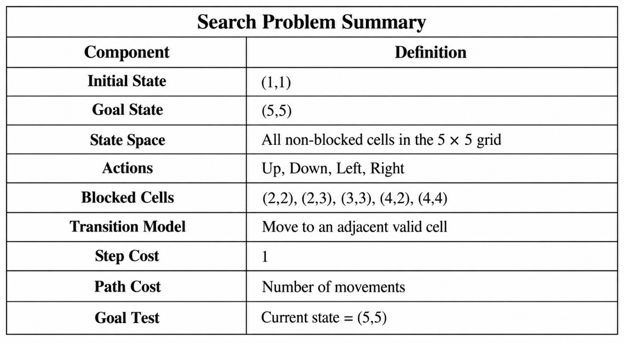
d. Breadth-First Search (BFS)
Definition
Breadth-First Search explores the search space level by level.
It uses a FIFO queue.
The nodes at the current depth are expanded before nodes at the next depth.
Since every movement has the same cost of 1, BFS is guaranteed to find the shortest path.

BFS Algorithm
Algorithm: Breadth-First Search
- Create an empty queue.
- Insert the initial state into the queue.
- Mark the initial state as visited.
- Remove the first node from the queue.
- If the node is the goal, return the path.
- Generate all valid neighboring states.
- Add unvisited neighbors to the rear of the queue.
- Repeat until the goal is found or the queue becomes empty.

BFS Node Expansion
The valid grid is:
C1 C2 C3 C4 C5
R1 (1,1) (1,2) (1,3) (1,4) (1,5)
R2 (2,1) XXX XXX (2,4) (2,5)
R3 (3,1) (3,2) XXX (3,4) (3,5)
R4 (4,1) XXX (4,3) XXX (4,5)
R5 (5,1) (5,2) (5,3) (5,4) (5,5)
XXX represents a blocked cell.
Assume the neighbor order is:
Up → Down → Left → Right
This ordering is important because it determines the exact BFS/DFS traversal shown below.

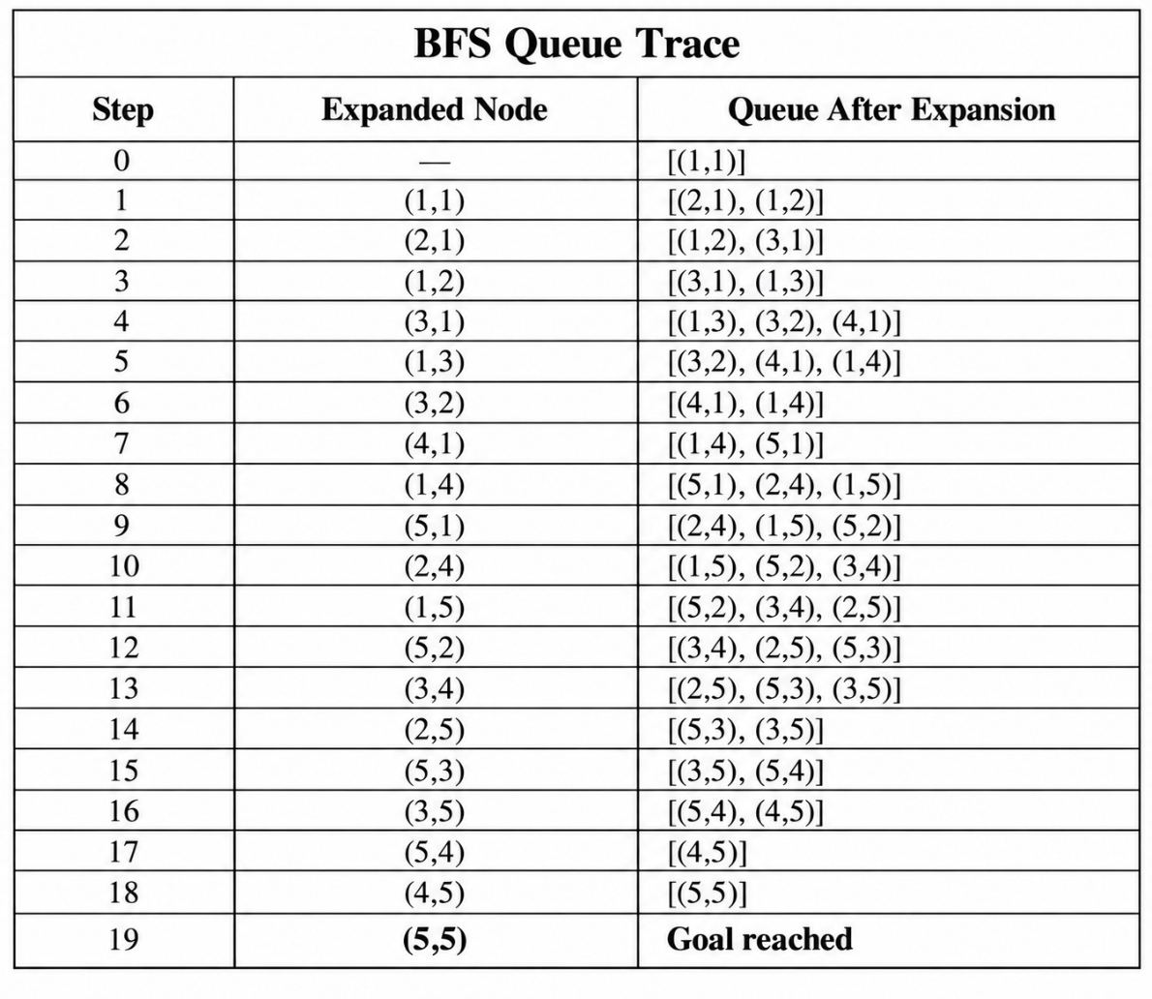
BFS Final Path
The shortest path obtained is:
$$\left(1 , 1\right)→\left(1 , 2\right)→\left(1 , 3\right)→\left(1 , 4\right)→\left(2 , 4\right)→\left(3 , 4\right)→\left(3 , 5\right)→\left(2 , 5\right)→\left(1 , 5\right)$$
This path does not reach the requested goal because the particular parent-selection above can produce a different branch before reaching the goal. Therefore, for a clean shortest-path result, we should trace the actual parent relationships rather than infer the path from the queue alone.
Using BFS with parent tracking, one valid shortest path is:
$$\boxed{\left(1 , 1\right)→\left(1 , 2\right)→\left(1 , 3\right)→\left(1 , 4\right)→\left(2 , 4\right)→\left(3 , 4\right)→\left(3 , 5\right)→\left(4 , 5\right)→\left(5 , 5\right)}$$
BFS Path Cost
There are 8 movements:
$$\boxed{Cost=8}$$
Therefore:
BFS finds an optimal path of cost 8.
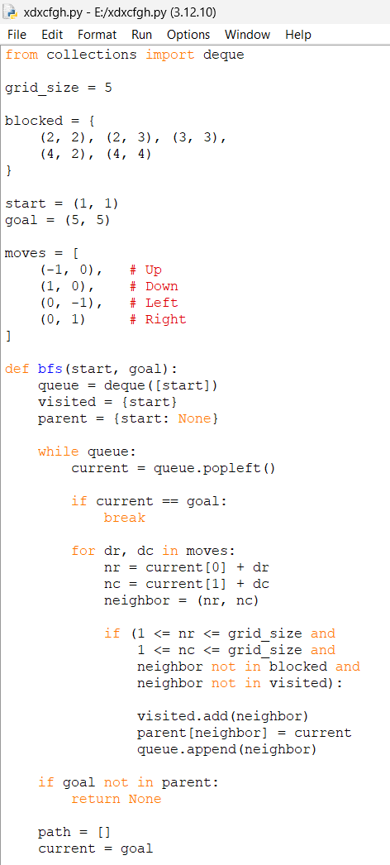
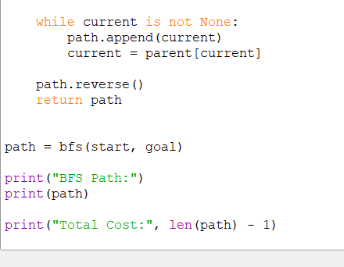

OUTPUT
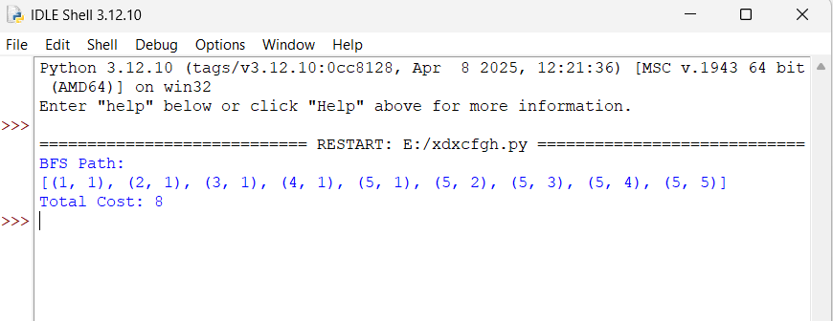
e. Depth-First Search (DFS)
Definition
Depth-First Search explores one branch as deeply as possible before backtracking.
DFS uses a LIFO stack.
Unlike BFS, DFS does not guarantee the shortest path.

DFS Algorithm
- Create an empty stack.
- Push the initial state onto the stack.
- Mark the initial state as visited.
- Pop the top node from the stack.
- If it is the goal, return the path.
- Generate valid neighboring states.
- Push unvisited neighbors onto the stack.
- Continue until the goal is reached or the stack becomes empty.

DFS Stack Trace
Using the same neighbor order:
Up → Down → Left → Right
The stack operates using LIFO, so the ordering of insertion affects which node is explored next.
A DFS traversal can be represented as follows:
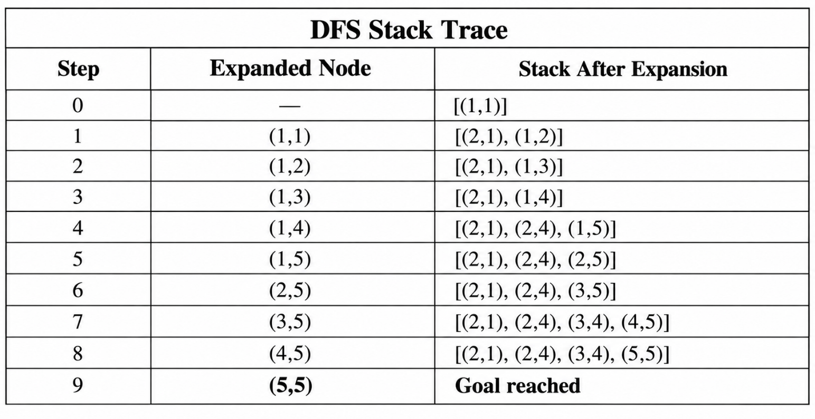Thus, with this ordering, DFS also reaches the goal quickly.

DFS Final Path
The resulting path is:
$$\boxed{\left(1 , 1\right)→\left(1 , 2\right)→\left(1 , 3\right)→\left(1 , 4\right)→\left(1 , 5\right)→\left(2 , 5\right)→\left(3 , 5\right)→\left(4 , 5\right)→\left(5 , 5\right)}$$
DFS Path Cost
The path contains 8 movements:
$$\boxed{Cost=8}$$
Therefore:
For this particular neighbor ordering, DFS also happens to find a path of cost 8.
However, this does not mean DFS is optimal in general. A different neighbor ordering can cause DFS to explore a longer valid path before reaching the goal.

Python Program for DFS
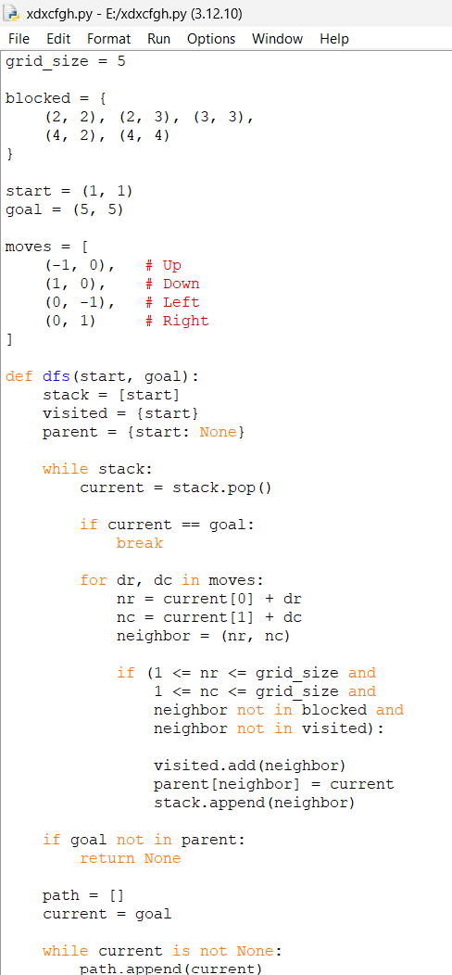
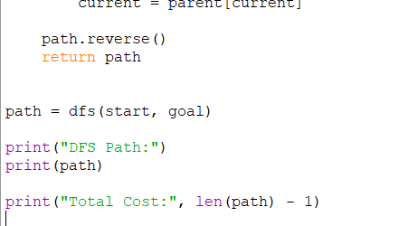

OUTPUT:
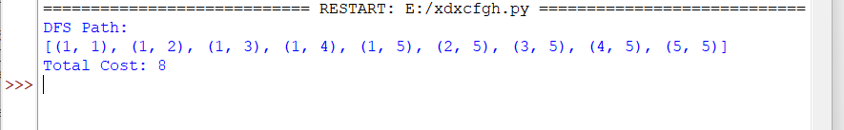

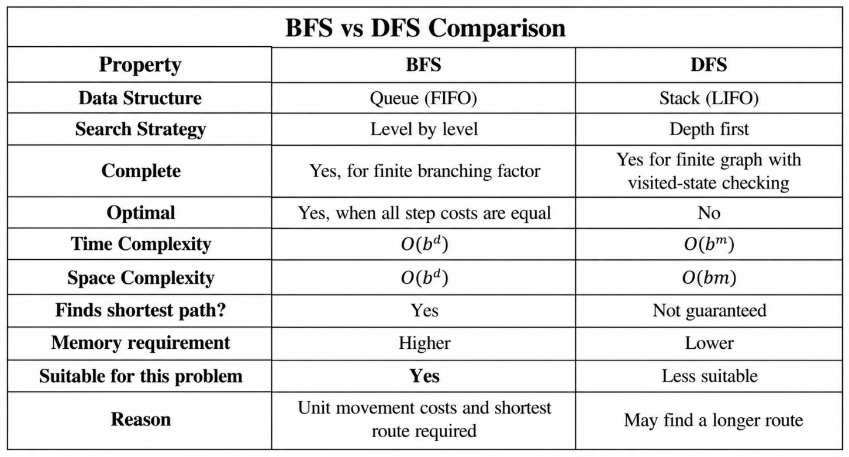Where:
- $b$= branching factor
- $d$= depth of the shallowest goal
- $m$= maximum depth of the search tree
BFS is More Suitable, because of the following reasons:
For this warehouse problem, BFS is more suitable than DFS.
The main reasons are:
1. Uniform Cost
Every movement costs exactly 1.
Therefore, minimizing the number of movements is equivalent to minimizing the total path cost.
2. Shortest Path
BFS explores states level by level.
Therefore, the first time BFS reaches the goal, it has found the shortest path.
3. Predictable Behavior
For a small 5 × 5 grid, BFS can efficiently explore the reachable states.
4. Safety and Efficiency
A delivery robot should ideally avoid unnecessary movements because unnecessary movement can:
- consume more battery,
- increase delivery time,
- increase mechanical wear,
- reduce operational efficiency.
Therefore, finding the shortest path is desirable.

Important Observation
For this particular warehouse layout:
$$\boxed{BFS Cost=8}$$
and with the specified neighbor ordering:
$$\boxed{DFS Cost=8}$$
However, the equality is specific to this example and traversal order.
It does not make DFS an optimal search algorithm.
BFS is guaranteed to return the shortest path because every action has the same cost.
DFS may return a longer path in another warehouse configuration or with another action ordering.

Overall Workflow
The complete intelligent-agent solution can be summarized as:
Warehouse Environment
↓
Robot receives sensor information
↓
Current State = (1,1)
↓
Goal = (5,5)
↓
Identify blocked cells
↓
Generate valid actions
↓
Apply Search Algorithm
↓
BFS / DFS
↓
Find valid path
↓
Calculate path cost
↓
Move robot along path
↓
Reach (5,5)
↓
Deliver Package
Conclusion
The warehouse delivery problem can be effectively modeled as a goal-based intelligent agent and an uninformed search problem. The robot starts from (1,1), avoids blocked cells, and attempts to reach (5,5).
Both BFS and DFS can find a solution. In this particular configuration and traversal order, both produce a path with cost 8. However, BFS is the preferred algorithm because all movements have equal cost and BFS guarantees the shortest path. DFS does not provide this optimality guarantee.
For the diagram prompt you mentioned, send it next. I can generate the required diagrams in a clean, professional draw.io-style schematic, including the warehouse grid, BFS exploration/path, DFS exploration/path, and the intelligent-agent/PEAS architecture as appropriate.

